Script;

1. Commodity_Scrapper.py, currently saves all data from the URL below, except for the Index Data as shown below.

It is executed daily.

URL:

[**https://tradingeconomics.com/commodities**](https://tradingeconomics.com/commodities)

1. **Need to Add Data for Indexes too**

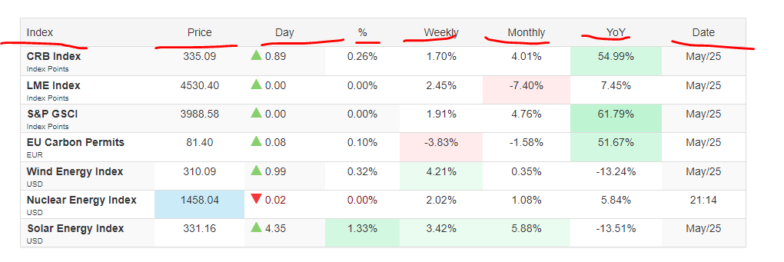

1. **Also need to add, Baltic Dry Index from following Link;**

[**https://tradingeconomics.com/commodity/baltic**](https://tradingeconomics.com/commodity/baltic)

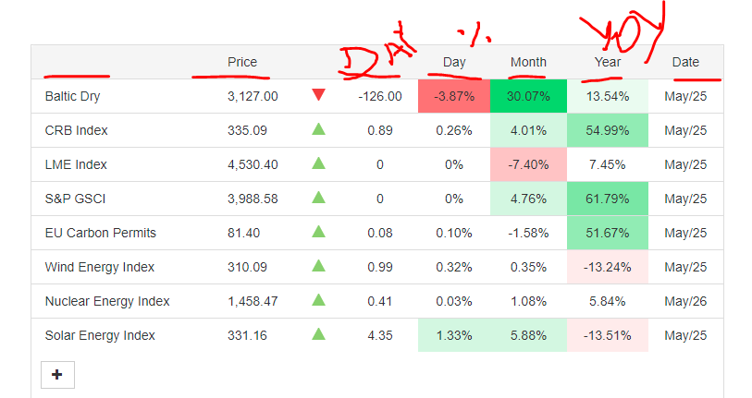

1. **Correspondence**

|  |  |  |
| --- | --- | --- |
| **DB Column** | **Web Page Column** | **Notes** |
| commodity_name | Baltic Dry, CRB Index…. |  |
| update_date | System Date |  |
| update_time | System Time |  |
| price | Price |  |
| change | Day | No Day Tag in case of Baltic |
| day_percent | % |  |
| week_percent | Weekly | No week_Percent for Baltic Dry |
| month_percent | Monthly |  |
| yoy_percent | YoY |  |
| currency | USD, EUR, Index Points.. |  |
| quantity | 1 |  |
| data_date | Date |  |